1. **What is Distributed Map?**
   1. This is really what the name suggests.
   2. It is a map where the data, the **Hazelcast Cluster** contains, is distributed across the **cluster members** (**Storage Nodes**)
2. **Suppose**: We have a Java Client which wants to store some customer names into a **map called Customers**.  
   A picture containing diagram

   Description automatically generated
   1. We use **Hazelcast API** to push this data into the map.  
      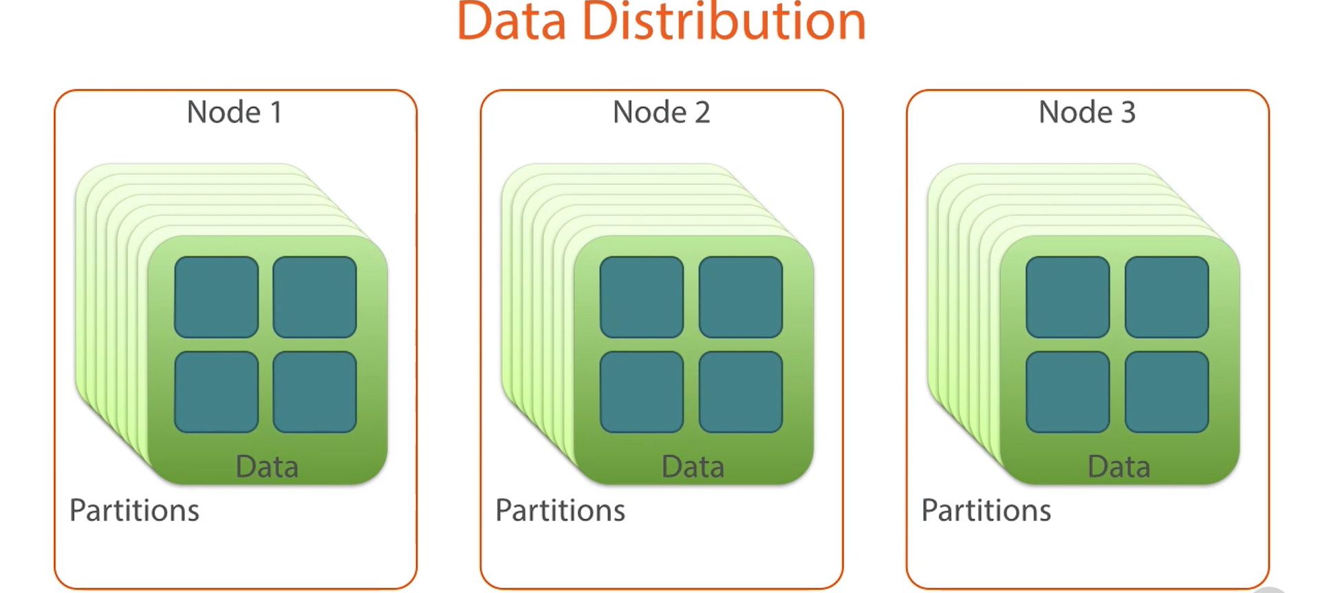
   2. Under the hood, Hazelcast **shards** all of the data into what it calls **partitions**.
   3. **Each partition** is assigned to a **single storage node**.
   4. **By default**, the # of partitions, it creates is 271.  
      So, with 3 Storage Nodes, approx.. 90 partitions get assigned to each storage node.  
      Map entries within the distributed Map get assigned to one of these partitions which partition is decided by Hazelcast.  
      It is generally based on a **Hashing Algorithm** on the map entry key.
   5. The result is 🡺 the partitions are assigned to **storage nodes** & **map entries** are assigned to **partitions**.
   6. Therefore, each of the customers will end up being stored on one of our 3 **storage nodes**.   
      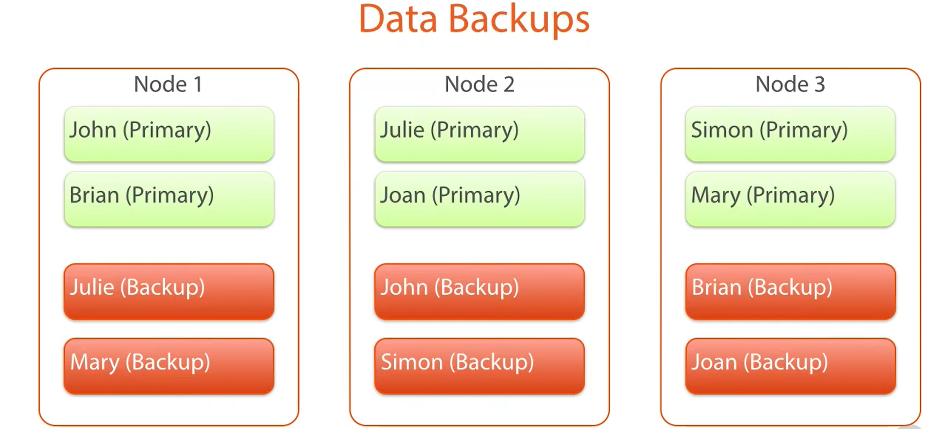
   7. Hazelcast **by default** stores a backup of the data on another node.  
      So, there will be a primary copy of the data on one node and a backup of the same data on another node.